**ShopNest Store Power BI Capstone**

1. **Top Categories by Total Price:**
   * Identify and visually represent the top 10 product categories by total sales.

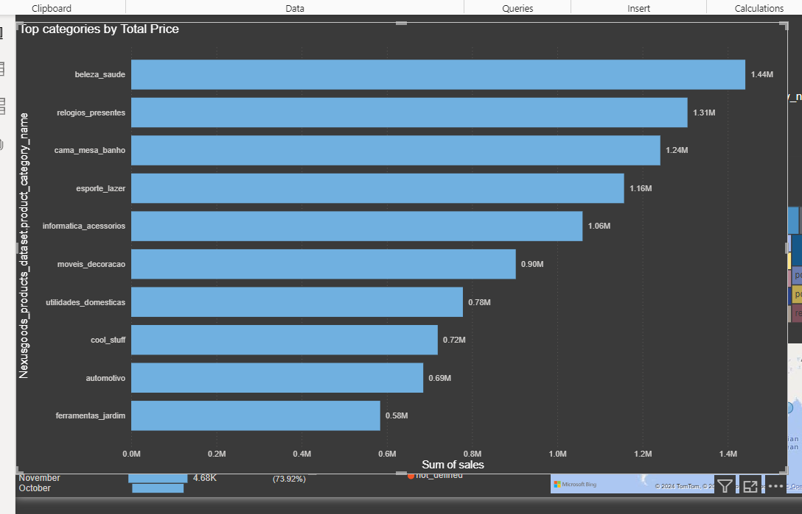

Here in this visualization we find the top categories as per total price and then we present it in a graph .

1. **Delayed Orders Analysis:**
   * Determine the number of delayed orders in each category. An order is considered delayed if the actual delivery date is later than the estimated delivery date.

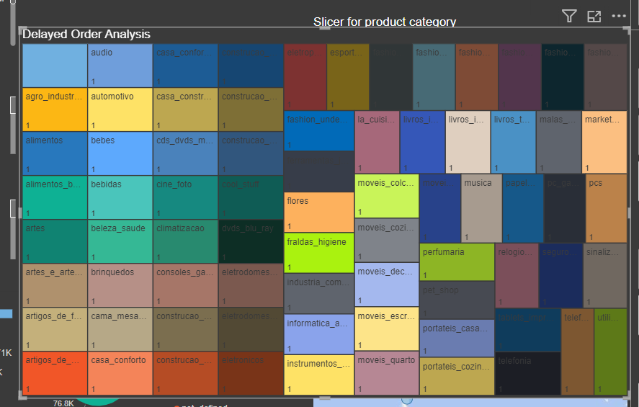

Here we use tree map to find the delayed number of orders as per each category and in dashboard also use Slicer for easy understanding as per each category .

1. **Monthly Comparison of Delayed and On-Time Orders:**
   1. Create a dynamic visual that compares the number of delayed orders to the number of orders received earlier for each month. Utilize the drillthrough cross-report feature to provide a detailed analysis of late and on-time deliveries.

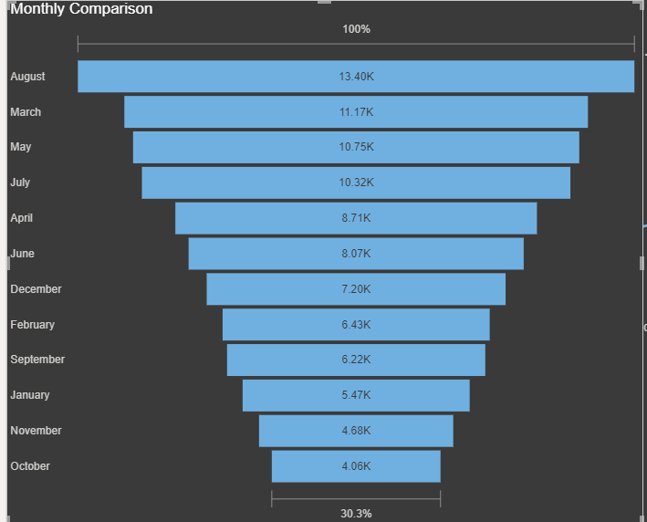

This visualization represent the monthly comparison of delayed – ontime orders

1. **Payment Method Analysis:**
   1. Analyze the most frequently used payment methods by customers using a visually appealing representation, such as a pie chart or other suitable visuals.
   2. 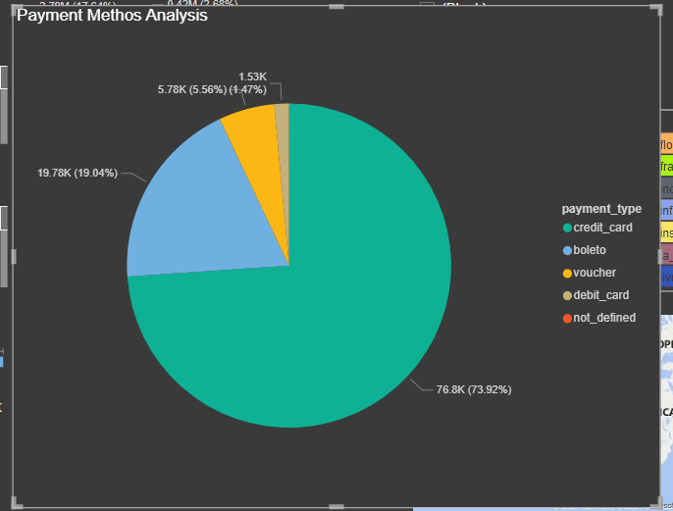

This pie chart represent that how many people will use different payment methods that are present in data.

1. **Product Rating Analysis:**
   1. Determine the top 10 highest-rated products and the bottom 10 lowest-rated products using a bar or column chart.
   2. 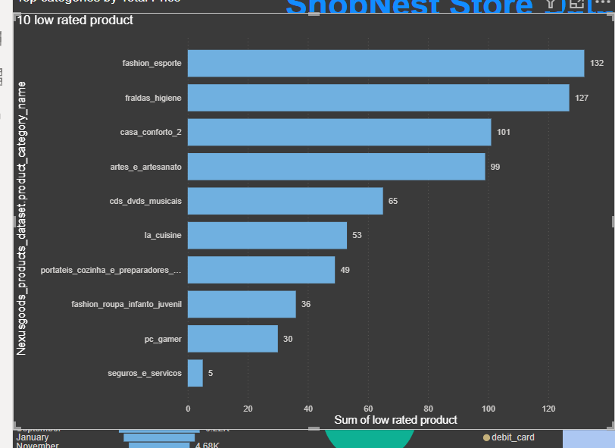

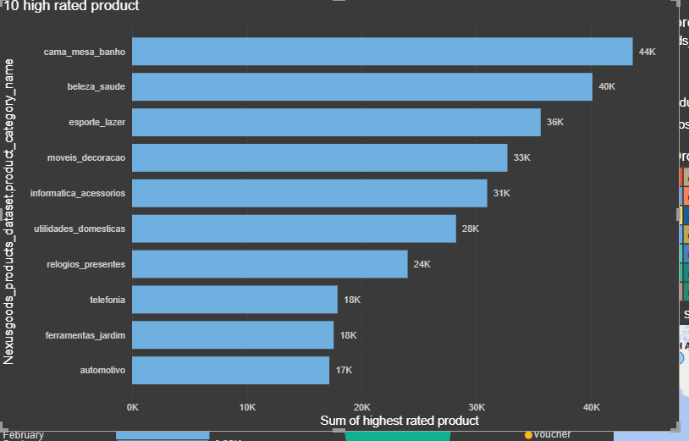

This both bar charts represent the 10 High rated and low rated products .

1. **State-wise Sales Analysis:**
   1. Identify and visually represent states with high and low sales, providing a clear understanding of regional sales performance.

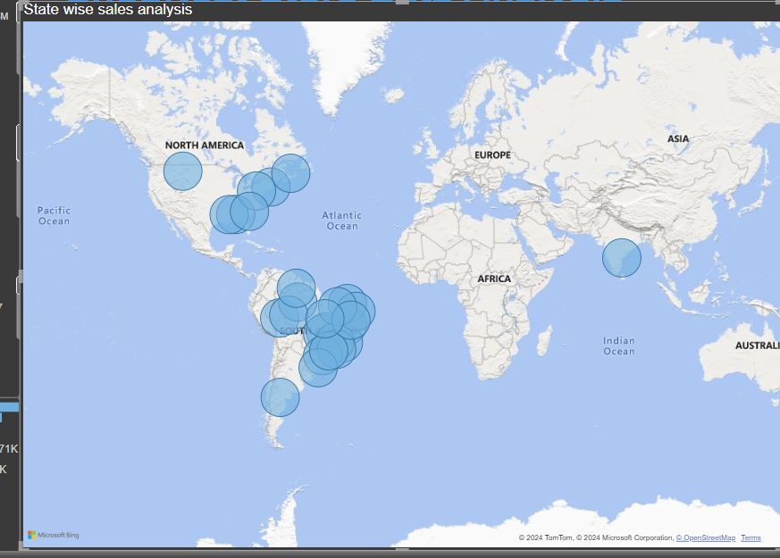

Here we use map to represent states as per geographic state it shows that how many sales are there as per particular state .

1. **Seasonal Sales Patterns:**

Investigate and visualize any seasonal patterns(Quarterly) or trends in sales data over the course of the year.

* 1. 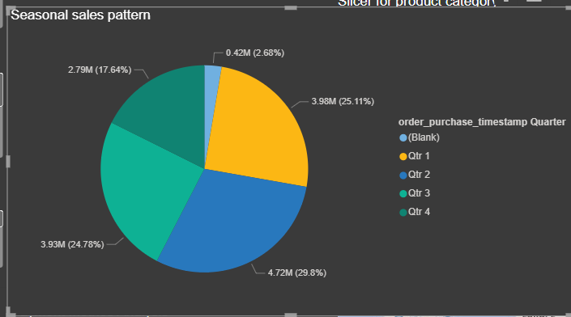

This pie chart represent sales as per quarters like how many sales are done in each quarter.

1. **Revenue Analysis:**
   * Determine the total revenue generated by ShopNest Store  and analyze how it changes over time(Yearly). Represent this information through suitable visuals to highlight trends and patterns.
   * 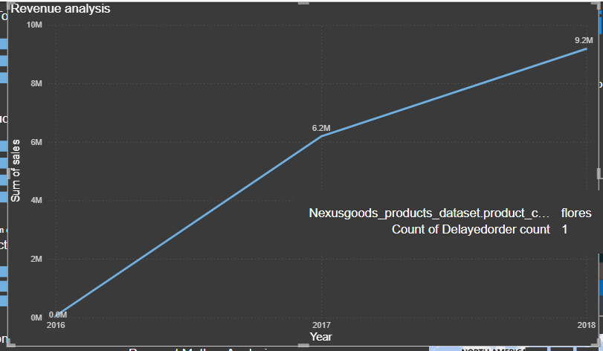

This Line chart represent the total revenue as per different years like how many revenue is there in year 2016,2017,2018.

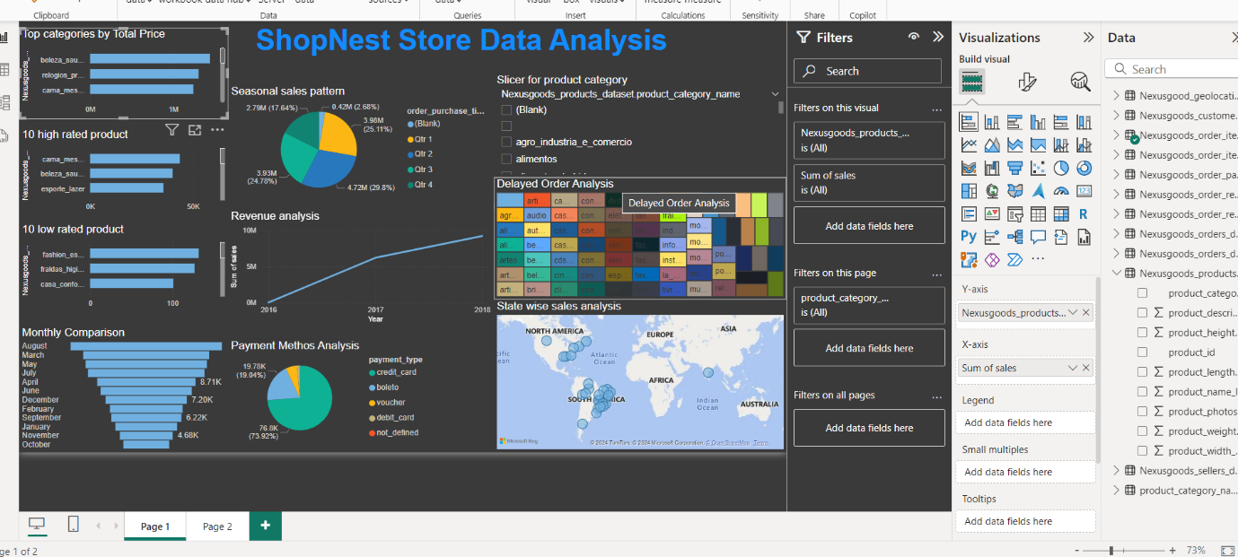

This picture represent the whole dashboard of ShopNest Store . In which I analyse that at different aspects what are the companies sales, revenue , high and low rated products , so it is the overall analysis of ShopNest Store .

By – Mehakpreet Kaur